Ideation Phase
Brainstorm & Idea Prioritization Template

Date | 08 DECEMBER 2025
Team ID (SkillWallet ID) | SWUID202560126
Project Name | Freelancing Application
Maximum Marks | 4 Marks

Brainstorm & Idea Prioritization
Step-1: Team Gathering, Collaboration and Select the Problem Statement
Primary Problem Statement:
Freelancers struggle to stand out and secure consistent, high-quality projects because current freelancing platforms are overcrowded, lack proper skill-verification, and do not provide enough tools for strong portfolio visibility — leading to frustration, low income, and unstable freelancing careers.

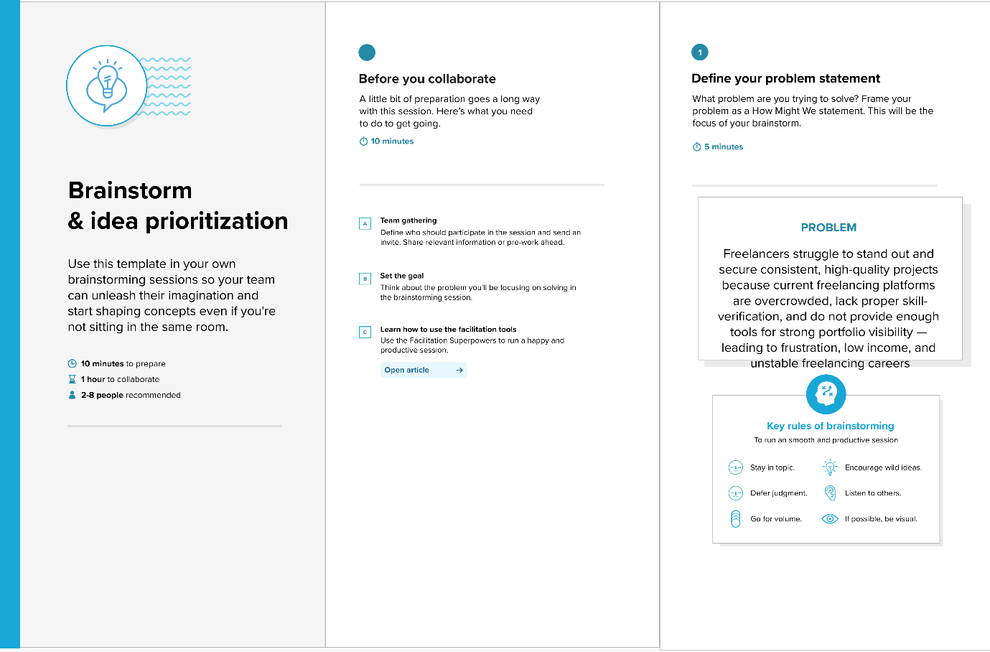

Step-2: Brainstorm, Idea Listing and Grouping
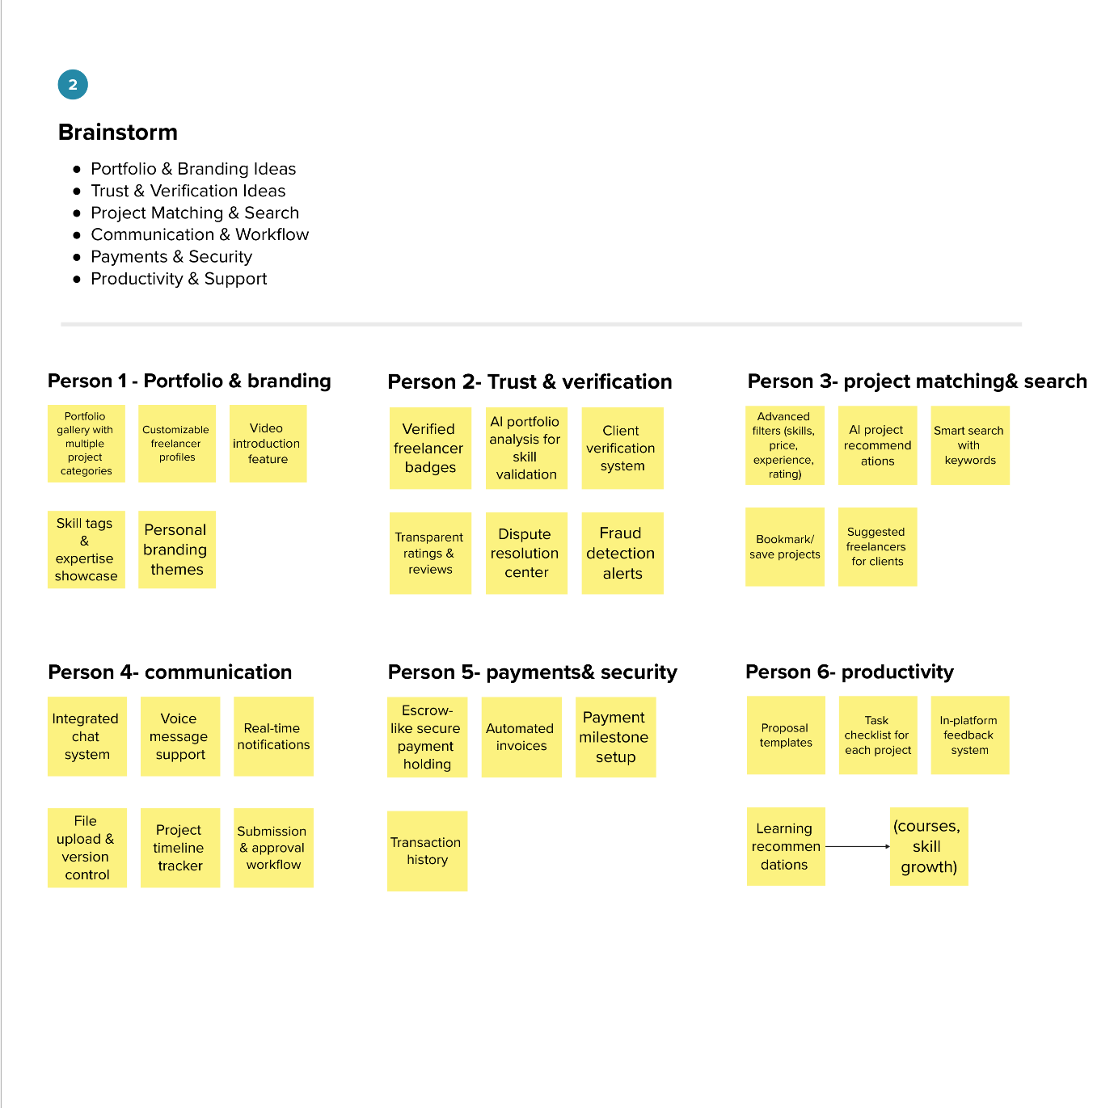

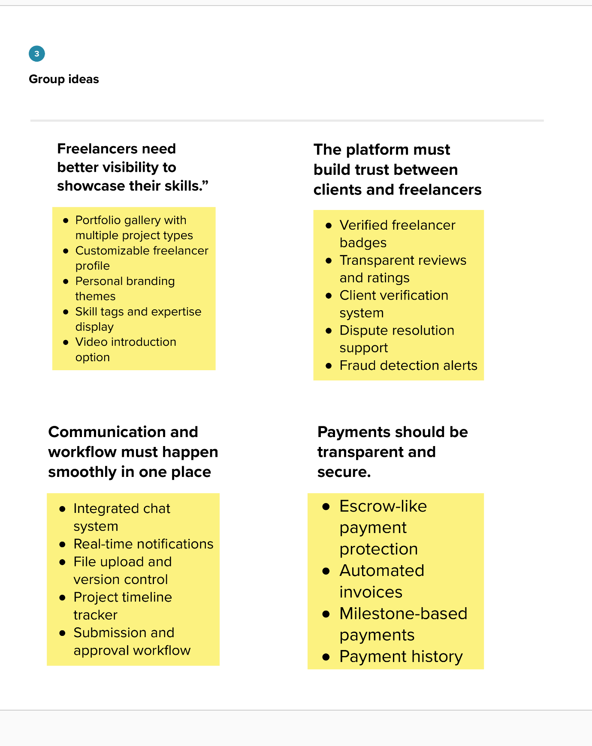

Step-3: Idea Prioritization
